ML Algorithms
Gradient Descent:
Gradient Descent is an optimization algorithm used to find the best values of parameters (like slope m and intercept b) by minimizing the error.
Keep adjusting the line until the error becomes as small as possible.
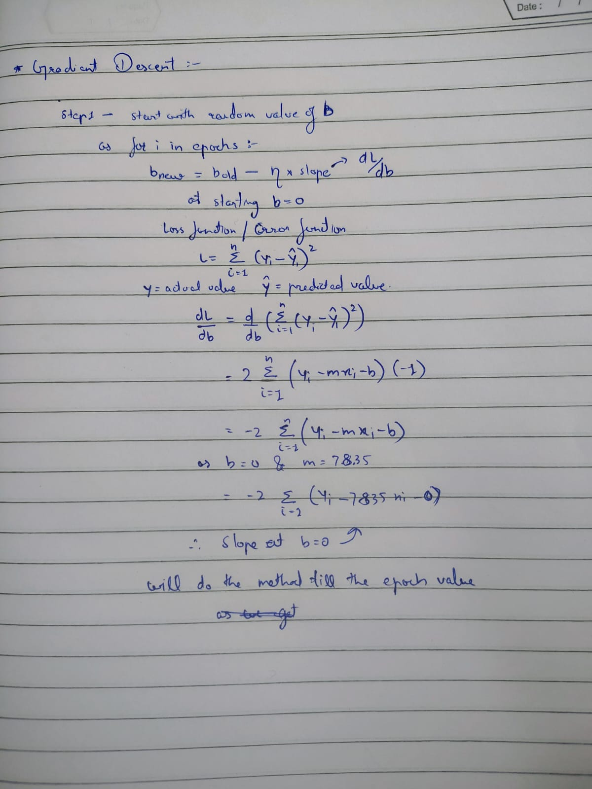
This above image is proof to find the value of b with gradient descent
And we can see slope is differentiation of loss function

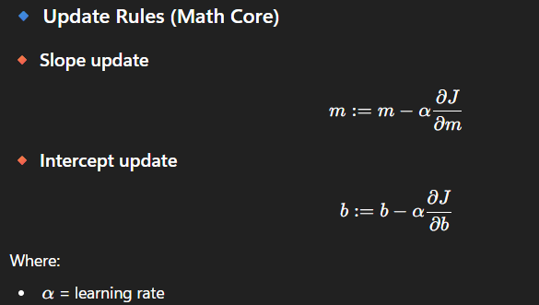

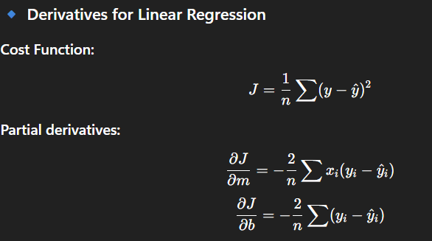

Getting both m and b values at a time
Proof
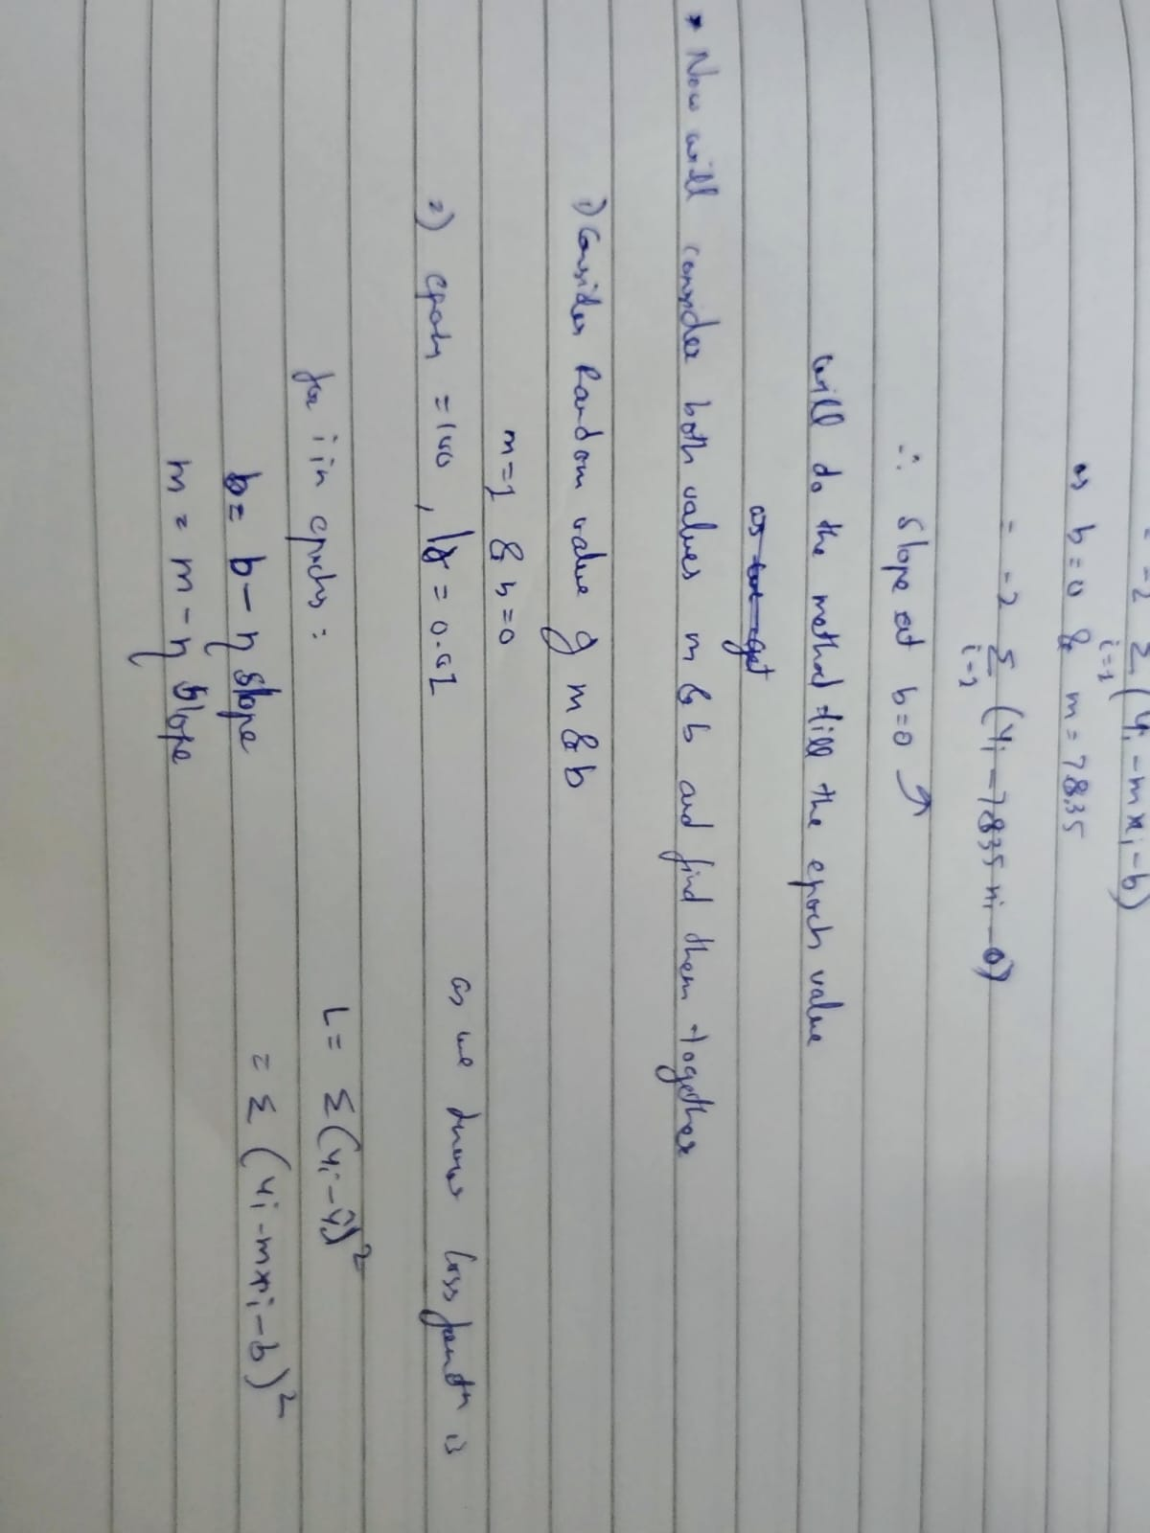

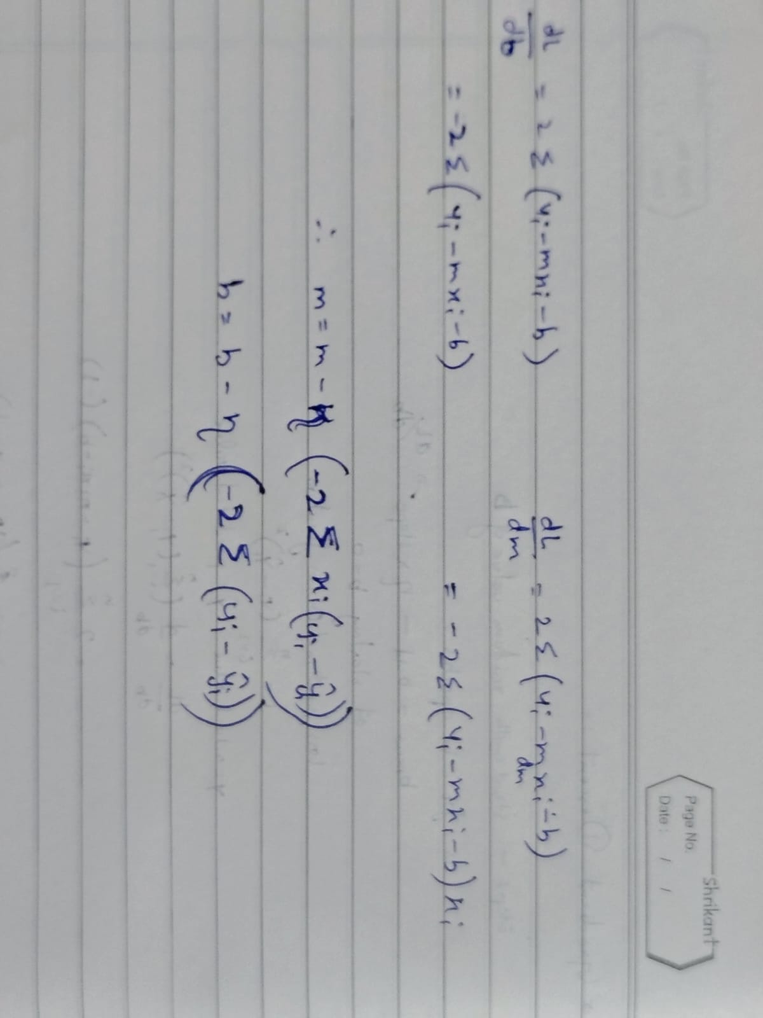

# we should always scale the data before gradient descent cause we get the plot very flat as you can see in right side so it descent is very fast towards the m and b values

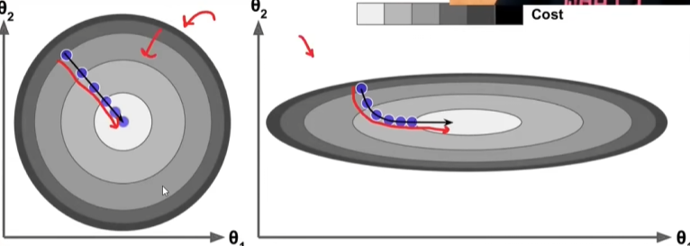

- Batch Gradient Descent:
It is the gradient descent we have done above
We will do it for multidimensional data
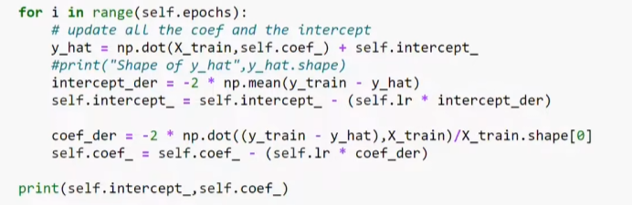

This code use the formulas 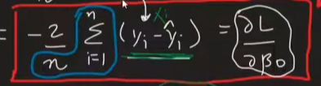
This is for the intercept where blue highlighted goes like

- Stochastic Gradient Descent:
As the batch GD was not good on large datasets and need so much computation cost therefore the SGD come in play

It becomes faster cause there is less epochs to compute weights and bias, and the data is not fully loads into memory
It takes the rows randomly and perform computation and this leaves to randomness in solution, does not return the perfect value just close to it

Formula for intercept:
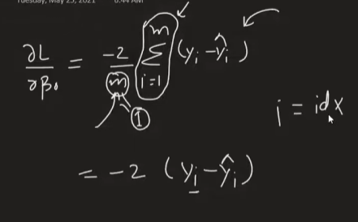

Where to apply it:
- Big data
- Non convex function: it consist of local minima
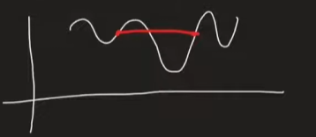
Learning Schedules:
- Improves convergence and stability
Why needed?
- Faster learning initially
- Fine tuning later
- Avoid overshooting minimum

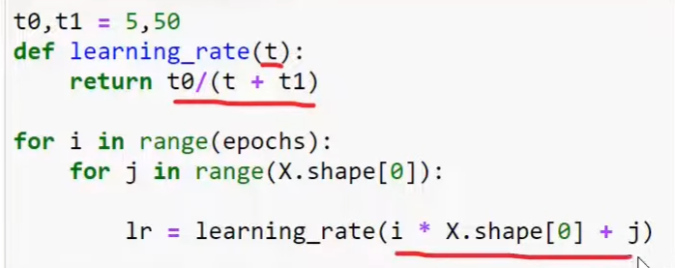
A learning rate schedule is a strategy where the learning rate changes during training instead of staying constant.
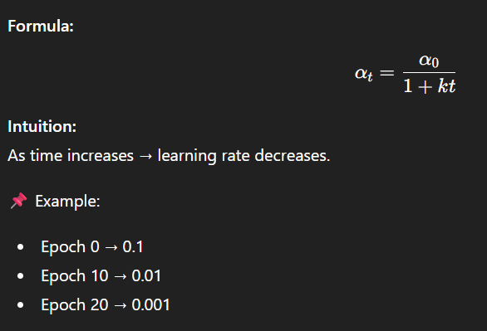

- MINI Batch GD:
Mini-Batch Gradient Descent is a version of gradient descent where the model updates its parameters using small chunks of data (mini-batches) instead of the entire dataset or a single data point.

How Mini-Batch Gradient Descent Works
- Shuffle the dataset
- Split it into mini-batches (e.g., size = 32 or 64)
- For each mini-batch:
  - Compute gradients
  - Update parameters
- One full pass over data = 1 epoch

This method is just like SDG but it decreases the randomness of the algo

Comparison of three algo on contour plot for finding lowest error :

